To back up the configuration of a FortiGate firewall
To back up the configuration of a FortiGate firewall, you can follow these steps:
1. Backup via Web GUI
- Log in to your FortiGate web interface.
- Go to Dashboard > Status.
- In the System Information widget, click Backup (for "Configuration Backup").
- Choose either:
  - Local PC to save the backup file to your computer, or
  - FTP if you want to save it to an FTP server.
- Save the file. The default filename includes the date of the backup, which can be helpful for versioning.
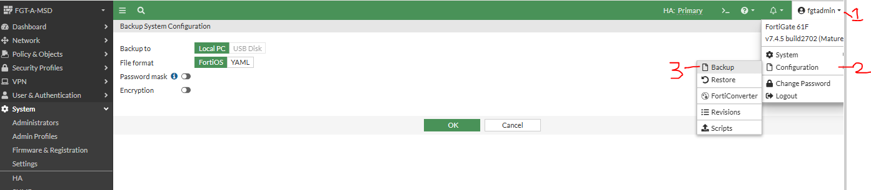
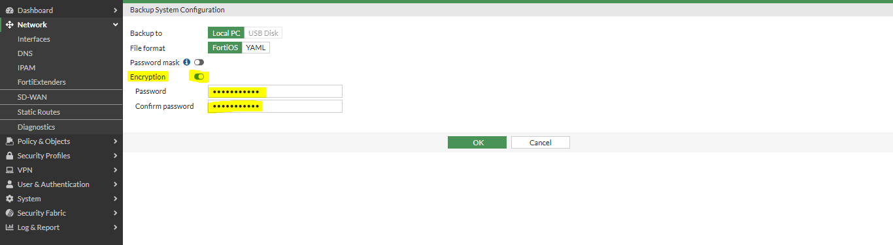
Note: - Enable Encryption and set Password during Backup and when restore the same backup then put same password as well.
“If not enable Encryption, then if anyone received the backup file he/she can read the configuration file of the firewall.”
2. Backup via CLI
- Log in to your FortiGate via SSH.
- Use the following command to back up to your local PC:
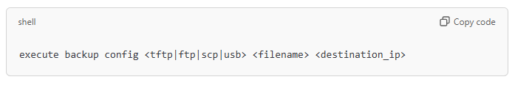
For example:
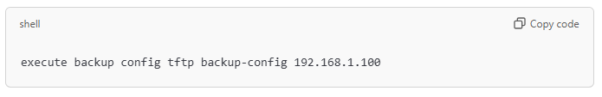
Replace backup-config with your preferred filename and 192.168.1.100 with the IP of TFTP server.
Note: For SCP backups, make sure SCP is enabled and you have a destination SCP server to store the file.
3. Automate Scheduled Backups (Optional)
FortiGate devices support automated backups using scripts or FortiManager for more complex configurations. This is useful if you need to keep periodic backups without manual effort.
Best Practices
- Always store backups in a secure location.
- Regularly update backups after configuration changes.
- Label your backup files with clear dates or version numbers.
Let me know if you need any more details on a specific method!

